MCP & DCC Use Case

Submitted to

Alpha Payments Cloud


Tarang Software Technologies Private Limited
Tarang Towers,
#400/2, Whitefield 100 ft road,
Hoody circle,
Bangalore, India
Phone: +91-80-41157777
WEB: www.tarangtech.com

© This document is exclusive property of Tarang software Technologies Private Limited. No part of this may reproduced in any form without written permission.

Document Change History

Ver# | Editor | Date | Reviewer | Approver | Changes made
0.1 | Vikash Ranjan | 03-sep-2012 | Bindu V |  | Draft version
1.0 | Vikash Ranjan | 10-sep-2012 | Bindu V |  | Base version
1.01 | Vikash Ranjan | 25-sep-2012 | Ronan |  | Updated version with Ronan’s review comments
1.02 | Vikash Ranjan | 28-sep-2012 | Ronan |  | Updated with 27th Sep review comments  Removed the use case for Pay page with MCP workflow  Updated the currency pairs configuration in get MCP rate list use case
Table of Contents

1 Introduction 4
2 Use Case: MCP Configuration 4
2.1 User Interface Information 4
2.1.1 User Interface details for MCP Configuration 4
3 Use Case: Get MCP Price List 5
3.1 User Interface Information 6
3.1.1 User Interface details 6
3.1.1.1 Validations 6
4 Use Case: DCC Configuration 6
4.1 User Interface Information 7
4.1.1 User Interface details 7
4.1.1.1 Validations 7
5 Use Case: paypage process with DCC 7
5.1 User Interface Information 9
5.1.1 User Interface details 9
5.1.1.1 Validations 9

Introduction

This document describes the use cases for Multi Currency Pricing (MCP) and Dynamic Currency Conversion (DCC) work-flow in APC System.

Use Case: MCP Configuration

Title | Configure MCP for Merchant
Requirement ID | RID-1123
Actors | APC User with appropriate privilege.
Description | Actor should be able to configure MCP for Merchant
Use case trigger | - Actor selects “Add Merchant” from the “Manage Merchant” menu in APC, “Add Merchant” section contains configuration for MCP (Yes/No). MCP is of type 'Standard' and 'Special'.
Main flow / Flow of Events | - On selecting 'Yes' for MCP for a particular Merchant, the configuration option is enabled.  - Need to select MCP configuration as a 'Standard' or 'Special'  - While saving this Merchant information, it associates above configuration in APC System for the Merchant.  - System persist the MCP configuration for the Merchant
Sub-flow/Alternate Flows/ Scenarios | 1a If MCP is not selected the standard and special option (Currency rate listing) cannot be selected for the merchant.  2a MCP 'Standard' and 'special' having two different currency conversion price list which applies for Merchant. Standard plan is the common currency rate listing , Special listing will include the merchant id specific currency rate listings
Assumptions | The currency rate plan listing for standard and special is available in the system.
Pre-conditions | Actor should be logged into the system & have the appropriate privilege to configure the MCP configuration for the newly added Merchant in APC System
Post-conditions | Actor is able to Add merchant in APC system with all set of MCP configuration values required.
Status | Open
Issues | Need to finalize the DCC provider ( Fxmicro pay or Monex) for receiving the rate plan with time zone
Business Rules | - On selection of ‘Standard’ MCP configuration, the Standard MCP rate list will apply for Merchant.  - On selection of ‘Special’ MCP configuration, the Special MCP rate list available in the special rates will apply for Merchant.

User Interface Information

User Interface details for MCP Configuration

Refer MCP configuration screen of the storyboard (Add Payment Method Configuration in merchant list screen)
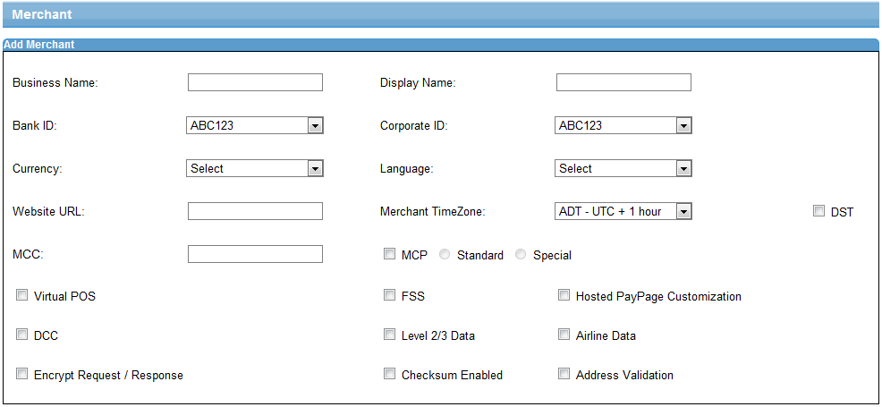

Use Case: Get MCP Price List

Title | Get MCP Price List
Requirement ID | RID-1134
Actors | Merchant Web portals of associated Merchant registered in APC
Description | Request for MCP rate list done by the merchant
Use case trigger | - Actor request for MCP rate list from APC System
Main flow / Flow of Events | - Actor request for rate list with parameter Merchant ID, Currency list, Timezone.  - APC System populates rate list based on the merchant configuration  - APC System responds back with rate list to actor.
Sub-flow/Alternate Flows/ Scenarios | 2a. APC System verifies request with the given parameter  2b. Validates the MCP configuration for the given Merchant Id.  2c. After Successful validation APC System populates the MCP rate list based on configuration
Assumptions | The currency supported by the merchant is available in the Currency rate list  Merchant is configured for MCP and the MCP currency is configured for this merchant
Pre-conditions | Merchant has association with APC with MCP configuration enabled to receive the currency rate list; The API exists to service the Rate list based on input parameters
Post-conditions | - Rate list will be available based on Merchant MCP configuration set and passed.
Status | Open
Issues
Business Rules | MCP price list will be based on Merchant MCP configuration(Standard/special), TimeZone  The MCP rate list will be retrieved based on the configuration entered in the MCP currency pairs for each merchant. If the From and To currency are not passed, then the rate list for the currency pairs configured in the configuration screen is returned. If a specific currency pair is passed, then just get the rates for that specific pair.

User Interface Information

User Interface details

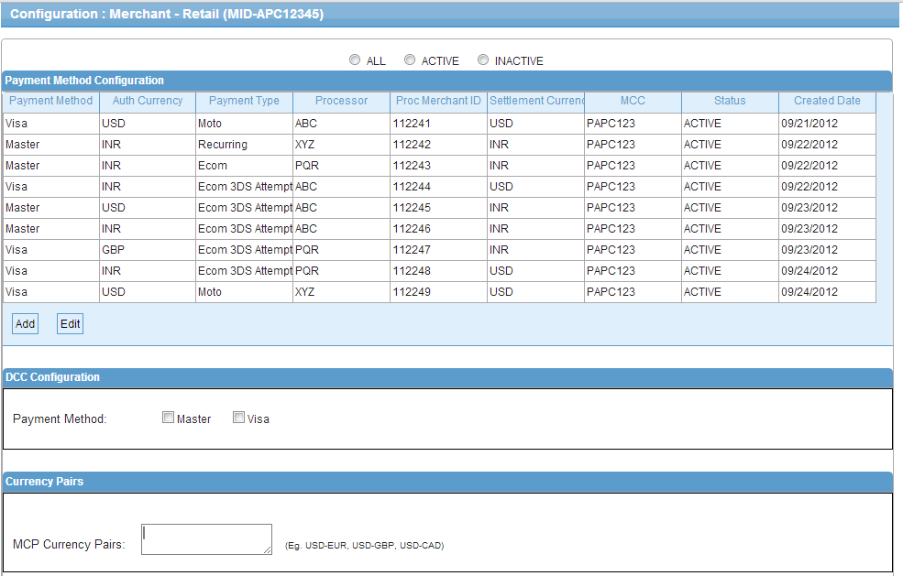

Validations
Will be updated later

Use Case: DCC Configuration

Title | Configuration of DCC for Merchant
Requirement ID | RID-1124
Actors | APC User with appropriate privilege.
Description | Actor should be able to configure DCC for Merchant
Use case trigger | - Actor selects “Configuration” from the “Manage Merchant” screen in APC; “DCC Configuration” section contains configuration value as/on Payment Method.
Main flow / Flow of Events | - Actor selects “Configuration” from the “Manage Merchant” screen in APC; “DCC Configuration” section contains configuration value for Payment Method.  - Actor selects 'payment methods' from the DCC configuration section from main configuration screen.  - While saving this Merchant information, it takes this payment method configuration in System for the Merchant.  - System persist the DCC configuration for the Merchant.
Sub-flow/Alternate Flows/ Scenarios | 2a If DCC is not selected as option then Merchant will not have DCC configuration.  2b If Actor opts for DCC then currency needs to be selected.
Assumptions | -
Pre-conditions | - Actor should be logged into the system & has the appropriate privilege to Add Merchant and set the DCC configuration in APC System  - While adding the Merchant DCC configured as 'Yes'.
Post-conditions | Merchant will be added in APC System with DCC enabled for selected payment methods.
Status | Open
Issues | None
Business Rules | To create the DCC configuration for each merchant

User Interface Information

User Interface details

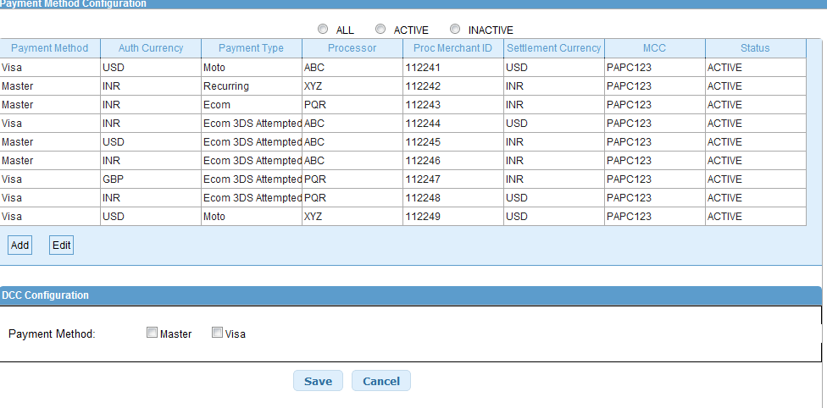

Validations

Will be added later

Use Case: paypage process with DCC

Title | Pay page transaction process with DCC enable in APC System
Requirement ID | RID-1135
Actors | Pay page transaction process originated from Merchant portals
Description | Pay page transaction process originated from Merchant portals with DCC enabled
Use case trigger | - Pay page transaction process
Main flow / Flow of Events | - APC System captures Pay page transaction request with Mandatory information like  Credit card information  Merchant Information  DCC configuration and payment method of Customer Card  Transaction currency and Merchant base currency info  Amount etc.  - Validates merchant information from pay page transaction request in APC System.  - Validates DCC configuration for given Merchant  - Transaction process  - If Customer Card Currency equals with Merchant base currency then transaction will process in auth currency as Merchant base currency  - DCC eligibility for the card is checked in the Gateway by the extended bin range check  - The DCC call to the DCC provider is made from the Pay page to receive the transaction currency value in the customer card currency  - If the customer card is eligible for DCC and the cardholder currency is a supported auth currency, Pay page will display rate and cardholder amount in cardholder currency and ask the cardholder for confirmation  - If Card currency supported by DCC currency list and card currency supported by Merchant Auth currencies list and Customer opt for DCC transaction then transaction will process in Customer card currency.  - If the customer opts-in, the transaction is processed in cardholder currency / merchant authorization currency  - Transaction get process in customer selected currency while choosing for DCC.
Sub-flow/Alternate Flows/ Scenarios | 4a Transaction will get process in Merchant Base currency if it fails to process as in point 4  5a. If the customer opts-out, or the DCC eligibility for the card holder is negative, then the transaction will get processed in Merchant base currency.
Assumptions
Pre-conditions | DCC configuration enabled for given Merchant
Post-conditions | Transaction gets process in customer card/selected currency.
Status | Open
Issues | None
Business Rules | DCC will be processed based on cardholder currency and card eligibility

User Interface Information

User Interface details
None

Validations
None

Note: For Later release, there will additional interface for the integration of multiple providers for the MCP /DCC services. There shall be an API that will be exposed for DCC check for API merchants

